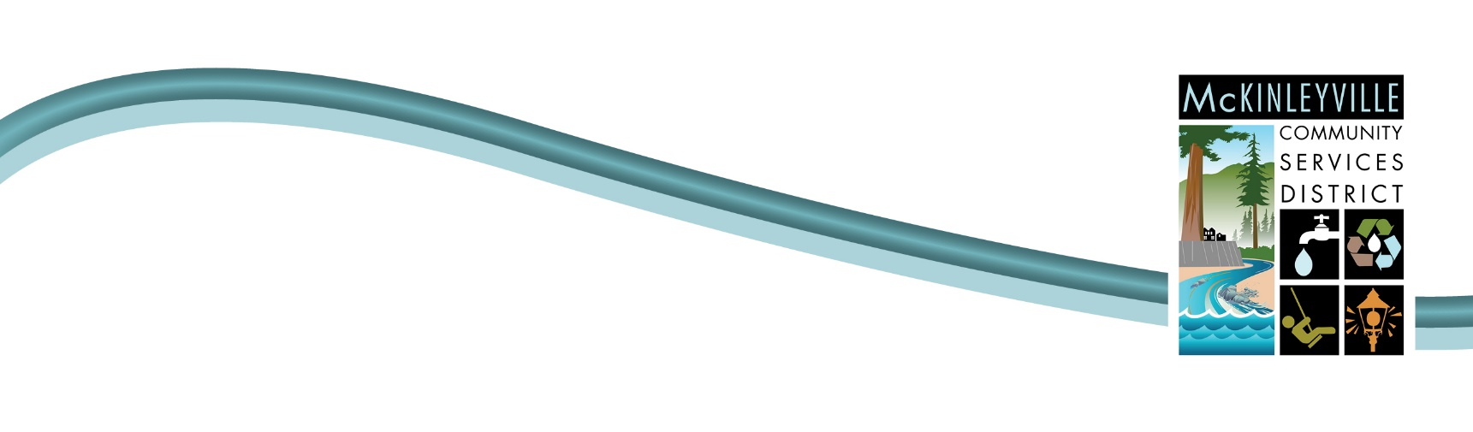

Mission statement of McKinleyville Community Services District:
“McKinleyville Community Services District provides authorized services fundamental to the health and well-being of the community.”

NOTICE IS HEREBY GIVEN THAT A REGULAR MEETING OF THE
PARK AND RECREATION COMMITTEE (PARC) WILL BE HELD
WEDNESDAY, NOVEMBER 20, 2024 AT 6:00pm

LOCATION: MCSD Conference Room
1656 Sutter Road
McKinleyville, California

Or

TELECONFERENCE Via ZOOM & TELEPHONE:
Use ZOOM MEETING ID: 826 4834 2851 (https://us02web.zoom.us/j/82648342851) or DIAL IN TOLL FREE: 1-669-900-6833 (No Password Required!)

To participate in person, please come to the MCSD Conference Room.

To participate by teleconference, please use the toll free number listed above, or join through the internet at the Zoom App with weblink and ID number listed above.
AGENDA
6:00 p.m. (Start Time Changed!)

a. Introductions, Call to Order & Flag Salute
b. Approval of Agenda
c. Approval of October 16, 2024 Meeting Minutes

Communications
III. Public Comment

IV. Possible Addition of Tribal Land Acknowledgement to PARC Procedures (Information)
V. Review and Consider Evan Schwartz’s Application for the Open Alternate Committee Member Seat (Action)
VI. Plant Markers for the Botanical Garden (Information)
VII. McKinleyville Community Forest Report (Information)
VIII. Parks & Recreation Director Report (Information)
IX. Ad Hoc Committee Reports (Information)

X. Discuss agenda topics for next meeting

XI. Adjournment (Estimated 8:00 pm)

Posted 5:00 pm on November 15, 2024
Pursuant to California Government Code Section 54957.5. this agenda and complete packet are available for public inspection on the web at https://mckinleyvillecsd.specialdistrict.org/parks-and-recreation-committee-parc-meetings or upon request at the MCSD office, 1656 Sutter Road, McKinleyville. If you would like to receive the complete packet via email, free of charge, contact the Board Secretary at (707)839-3251 to be added to the mailing list.

McKinleyville Community Services District will, on request, make agendas available in appropriate alternative formats to persons with a disability, as required by Section 202 of the Americans with Disabilities Act of 1990 (42 U.S.C. Sec. 12132), and the federal rules and regulations adopted in implementation thereof. Individuals who need this agenda in an alternative format or who need a disability-related modification or accommodation in order to participate in the meeting should contact the Board Secretary at (707) 839-3251. Notification 48 hours prior to the meeting will enable the District to make reasonable arrangements for accommodations.

